**TUGAS PRAKTIKUM ALGORITMA & STRUKTUR DATA**

**Jilid 8**



**Oleh :**

**Nama : Rosi Arif Mulyadi**

**NRP : 3121522021**

**Prodi : D3 Teknik Informatika PENS PSDKU Sumenep**

**Kelas : 1 ITA D3 Sumenep**

**Dosen :**

**LUSIANA AGUSTIEN M.Kom**

**POLITEKNIK ELEKTRONIKA NEGERI SURABAYA**

**MODUL 4**

**LINKED LIST (Double LINKED LIST NON CIRCULAR)**

**B. Kegiatan Praktikum**

1. Lakukan Pembenahan terhadap listing program yang di berikan pada implementasi linked list non circular diatas.

Jawab :

Listing Program :

#include <stdio.h>

#include <stdlib.h>

struct node

{

struct node *prev;

struct node *next;

int data;

};

struct node *head;

void insertion_beginning();

void insertion_last();

void insertion_specified();

void deletion_beginning();

void deletion_last();

void deletion_specified();

void display();

void search();

void insertion_beginning()

{

struct node *ptr;

int item;

ptr = (struct node *)malloc(sizeof(struct node));

if(ptr == item)

{

printf("\nOVERFLOW");

}

else

{

printf("\n Input Data : ");

scanf("%d", &item);

if(head==NULL)

{

ptr->next = NULL;

ptr->data = item;

ptr->prev = NULL;

head=ptr;

}

else

{

ptr->data = ptr;

ptr->next = NULL;

ptr->prev = head;

head->prev = NULL;

head=ptr;

}

printf("\nNode telah di inputkan\n");

}

}

void insertion_last()

{

struct node *ptr, *temp;

int item;

ptr = (struct node *)malloc(sizeof(struct node));

if(ptr == NULL)

{

printf("\nOVERFLOW");

}

else

{

printf("\nInput nilai data : ");

scanf("%d", &item);

ptr->data=item;

if(head == NULL)

{

ptr->next = NULL;

ptr->prev = NULL;

head = ptr;

}

else

{

temp = head;

while(temp->next!=NULL)

{

temp = temp->next;

}

temp->next = ptr;

ptr->prev = temp;

ptr->next = NULL;

}

}

printf("\nNode sudah di inputkan\n");

}

void insertion_specified()

{

struct node *ptr, *temp;

int item, loc, i;

ptr = (struct node *)malloc(sizeof(struct node));

if(ptr == NULL)

{

printf("\nOVERFLOW");

}

else

{

temp=head;

printf("Input lokasi yang akan di sisipkan node baru : ");

scanf("%d", &loc);

for(i=0; i<loc; i++)

{

temp = temp->next;

if(temp == NULL)

{

printf("\n Linked list hanya memiliki %d elements : ", loc);

return;

}

}

printf("Inputkan data : ");

scanf("%d", &item);

ptr->data = item;

ptr->next = temp->next;

ptr->prev = temp;

temp->next = ptr;

temp->next->prev=ptr;

printf("\nNode sudah di inputkan\n");

}

}

void deletion_beginning()

{

struct node *ptr;

if(head == NULL)

{

printf("\nUNDERFLOW");

}

else if(head->next == NULL)

{

head = NULL;

free(head);

printf("\nNode berhasil di hapus\n");

}

else

{

ptr = head;

head = head->next;

head->prev = NULL;

free(ptr);

printf("\nNode berhasil di hapus\n");

}

}

void deletion_last()

{

struct node *ptr;

if(head == NULL)

{

printf("\nUNDERFLOW");

}

else if(head->next == NULL)

{

head = NULL;

free(head);

printf("\nNode berhasil di hapus\n");

}

else

{

ptr = head;

if(ptr->next != NULL)

{

ptr = ptr->next;

}

ptr->prev->next = NULL;

free(head);

printf("\nNode berhasil di hapus\n");

}

}

void deletion_specified()

{

struct node *ptr, *temp;

int val;

printf("\n Inputkan data yang akan di hapus : ");

scanf("%d", &val);

ptr = head;

while(temp->next != NULL)

{

ptr = ptr->next;

if(ptr->next == NULL)

{

printf("\n Tidak dapat di deleted\n");

}

else if(ptr->next->next == NULL)

{

ptr->next = NULL;

}

else

{

temp = ptr->next;

ptr->next = temp->next;

temp->next->prev = ptr;

free(temp);

printf("\nNode deleted\n");

}

}

}

void display()

{

struct node *ptr;

printf("\n Tampilkan list : \n");

ptr = head;

while(ptr != NULL)

{

printf("%d\n", ptr->data);

ptr = ptr->next;

}

}

void search()

{

struct node *ptr;

int item, i=0, flag;

ptr = head;

if(ptr == NULL)

{

printf("\nList kosong\n");

}

else

{

printf("\nInputkan data yang akan dicari : \n");

scanf("%d", &item);

while(ptr!=NULL)

{

if(ptr->data == item)

{

printf("\n Data yang dicari ada di dalam node %d ", i);

flag=0;

break;

}

else

{

flag=1;

}

i++;

ptr = ptr->next;

}

if(flag==1)

{

printf("\nItem tidak ditemukan\n");

}

}

}

void main()

{

int choice = 0;

while(choice != 9)

{

printf("\n*********Main Menu*********\n");

printf("\n================================================\n");

printf("\n1.Insert in beginning\n2.Insert at last\n3.Insert at any random location\n4.Delete from beginning\n5.Delete from last\n6.Delete the node after the given data\n7.Search\n8.Show\n9.Exit\n");

printf("\n Input pilihan ?\n");

scanf("\n%d", &choice);

switch(choice)

{

case 1:

insertion_beginning();

break;

case 2:

insertion_last();

break;

case 3:

insertion_specified();

break;

case 4 :

deletion_beginning();

break;

case 5:

deletion_last();

break;

case 6:

deletion_specified();

break;

case 7:

search();

break;

case 8:

display();

break;

case 9:

exit(0);

break;

default:

printf("Input pilihan dengan benar");

}

}

}

Output :

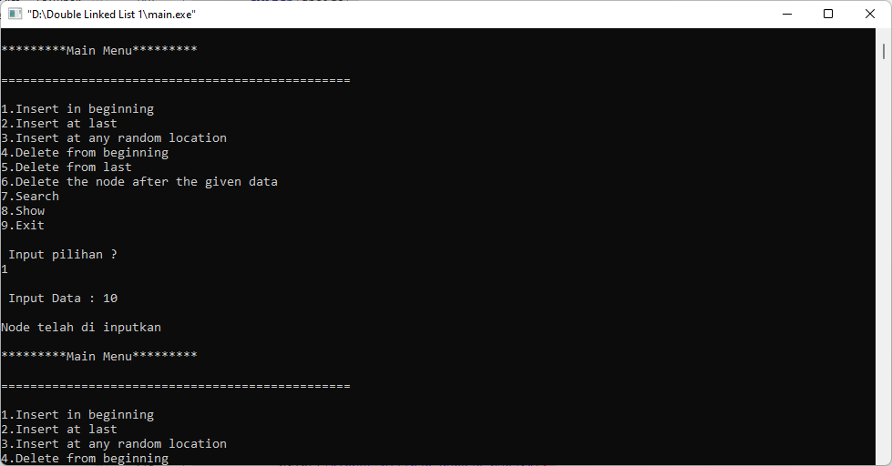

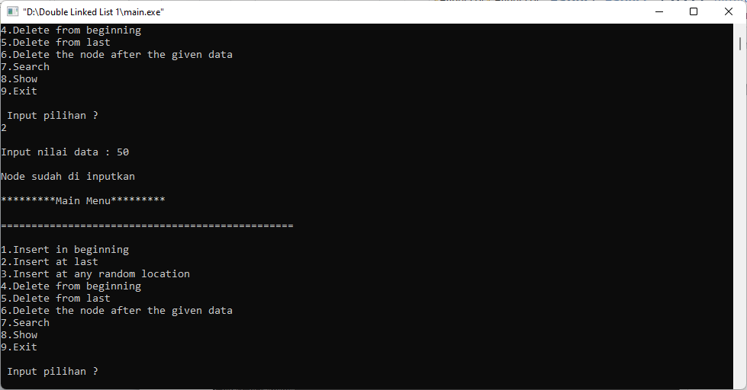

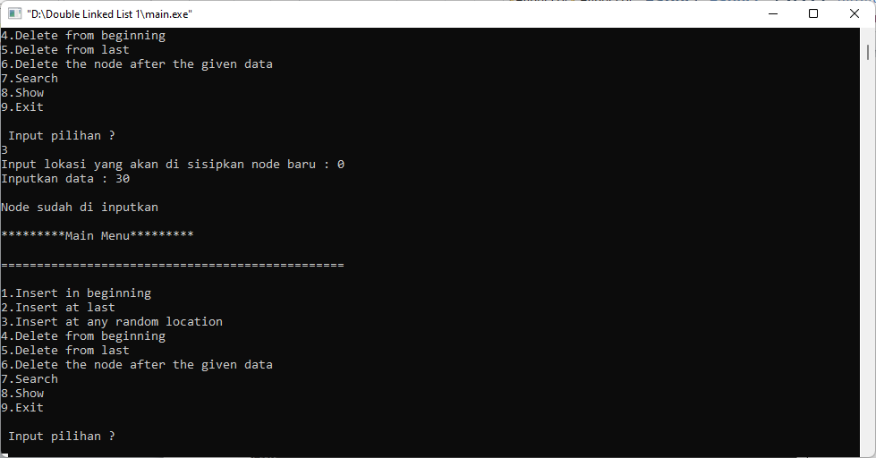

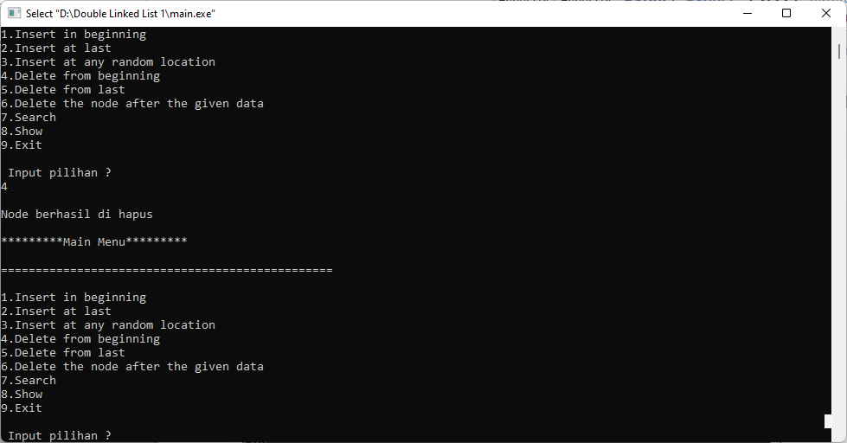

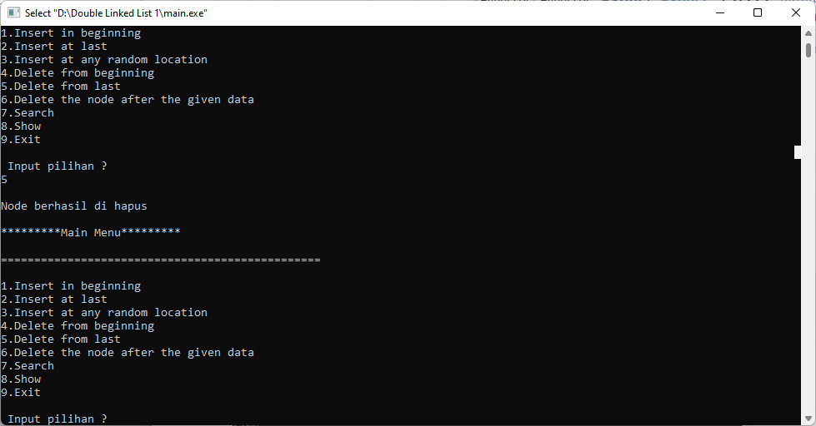

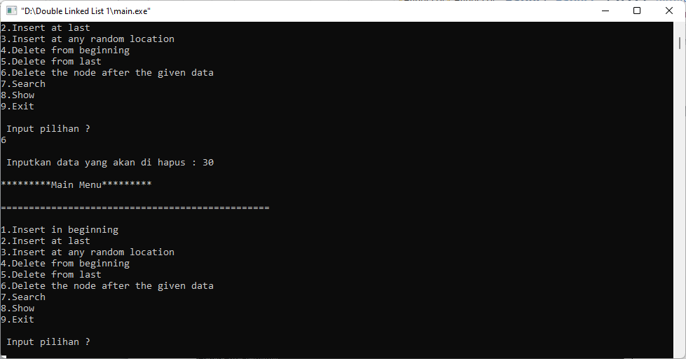

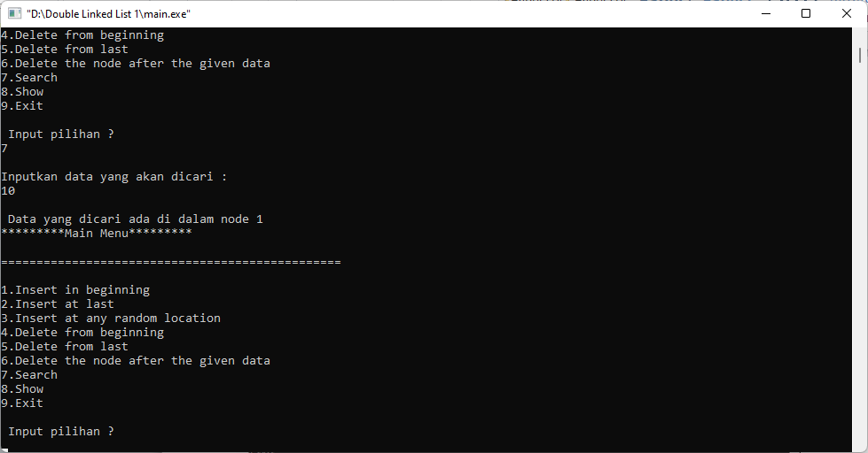

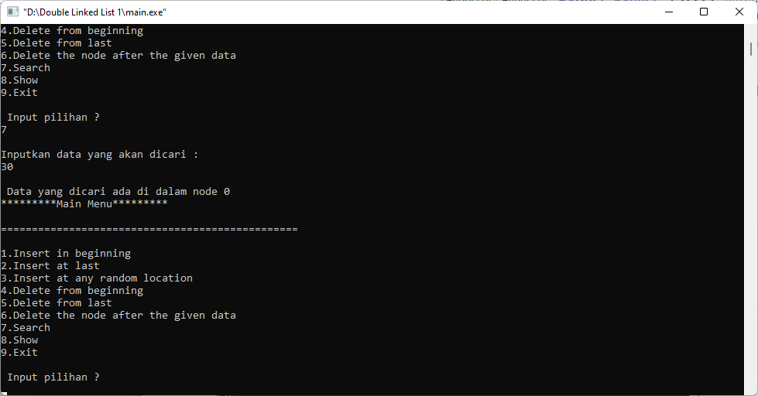

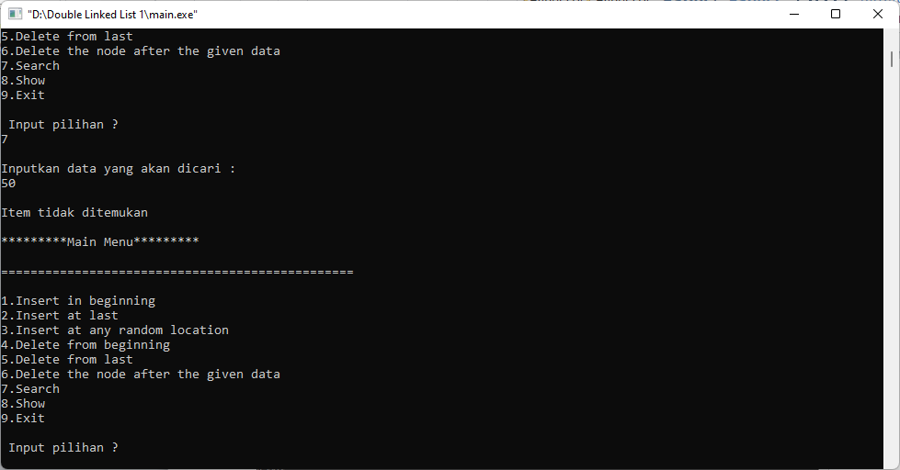

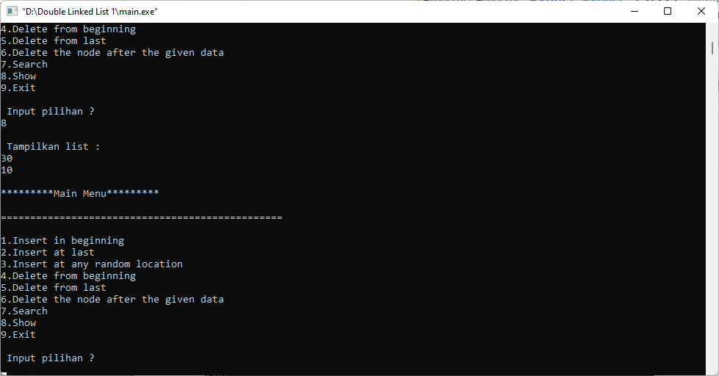

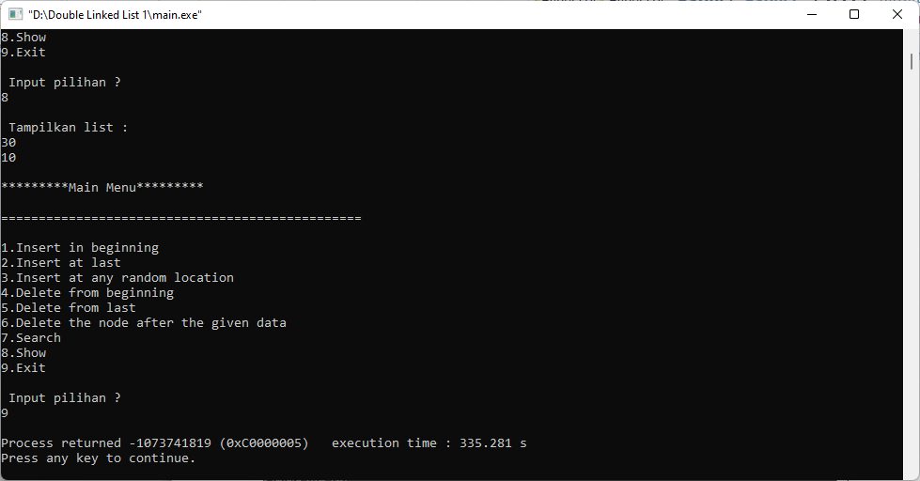

2. Buatlah dan tuliskan langkah – langkah algoritma yang disajikan pada tiap function yang dibuat pada implementasi linked list non circular diatas.

Jawab :

* **ALgoritma Menginpukan Data :**

**Step 1: IF ptr = NULL Write OVERFLOW Go to Step 9 [END OF IF]**

**Step 2: SET NEW_NODE = ptr**

**Step 3: SET ptr = ptr -> NEXT**

**Step 4: SET NEW_NODE -> DATA = VAL**

**Step 5: SET NEW_NODE -> PREV = NULL**

**Step 6: SET NEW_NODE -> NEXT = START**

**Step 7: SET head -> PREV = NEW_NODE**

**Step 8: SET head = NEW_NODE**

**Step 9: EXIT**

* **Algoritma Menghapus Data :**

**Step 1: IF HEAD = NULL Write UNDERFLOW Go to Step 7 [END OF IF]**

**Step 2: SET TEMP = HEAD**

**Step 3: REPEAT STEP 4 WHILE TEMP->NEXT != NULL**

**Step 4: SET TEMP = TEMP->NEXT [END OF LOOP]**

**Step 5: SET TEMP ->PREV-> NEXT = NULL**

**Step 6: FREE TEMP**

**Step 7: EXIT**

**C. Tugas Praktikum**

1. Buatlah program untuk menginputkan data pada double linked list (di awal, akhir, dan di tempat tertetu) namu pada saat kita menginputkan data 0, maka otomatis proses penginputan data akan berhenti.

Jawab :

Listing Program :

#include <stdio.h>

#include <stdlib.h>

struct node

{

struct node *prev;

struct node *next;

int data;

};

struct node *head;

void insertion_beginning();

void insertion_last();

void insertion_specified();

void insertion_beginning()

{

struct node *ptr;

int angka;

ptr = (struct node *)malloc(sizeof(struct node));

if(ptr == angka)

{

printf("\nOVERFLOW");

}

else

{

printf("\n Input Data : ");

scanf("%d", &angka);

if(angka==0){

exit(0);

}

if(head==NULL)

{

ptr->next = NULL;

ptr->data = angka;

ptr->prev = NULL;

head=ptr;

}

else

{

ptr->data = ptr;

ptr->next = NULL;

ptr->prev = head;

head->prev = NULL;

head=ptr;

}

printf("\nNode telah di inputkan\n");

}

}

void insertion_last()

{

struct node *ptr, *temp;

int angka;

ptr = (struct node *)malloc(sizeof(struct node));

if(ptr == NULL)

{

printf("\nOVERFLOW");

}

else

{

printf("\nInput nilai data : ");

scanf("%d", &angka);

if(angka==0){

exit(0);

}

ptr->data=angka;

if(head == NULL)

{

ptr->next = NULL;

ptr->prev = NULL;

head = ptr;

}

else

{

temp = head;

while(temp->next!=NULL)

{

temp = temp->next;

}

temp->next = ptr;

ptr->prev = temp;

ptr->next = NULL;

}

}

printf("\nNode sudah di inputkan\n");

}

void insertion_specified()

{

struct node *ptr, *temp;

int angka, loc, i;

ptr = (struct node *)malloc(sizeof(struct node));

if(ptr == NULL)

{

printf("\nOVERFLOW");

}

else

{

temp=head;

printf("Input lokasi yang akan di sisipkan node baru : ");

scanf("%d", &loc);

for(i=0; i<loc; i++)

{

temp = temp->next;

if(temp == NULL)

{

printf("\n Linked list hanya memiliki %d elements : ", loc);

return;

}

}

printf("Inputkan data : ");

scanf("%d", &angka);

if(angka==0){

exit(0);

}

ptr->data = angka;

ptr->next = temp->next;

ptr->prev = temp;

temp->next = ptr;

temp->next->prev=ptr;

printf("\nNode sudah di inputkan\n");

}

}

void display()

{

struct node *ptr;

printf("\n Tampilkan list : \n");

ptr = head;

while(ptr != NULL)

{

printf("%d\n", ptr->data);

ptr = ptr->next;

}

}

void search()

{

struct node *ptr;

int item, i=0, flag;

ptr = head;

if(ptr == NULL)

{

printf("\nList kosong\n");

}

else

{

printf("\nInputkan data yang akan dicari : \n");

scanf("%d", &item);

while(ptr!=NULL)

{

if(ptr->data == item)

{

printf("\n Data yang dicari ada di dalam node %d ", i);

flag=0;

break;

}

else

{

flag=1;

}

i++;

ptr = ptr->next;

}

if(flag==1)

{

printf("\nItem tidak ditemukan\n");

}

}

}

void main()

{

int choice = 0;

while(choice != 6)

{

printf("\n*********Main Menu*********\n");

printf("\n================================================\n");

printf("1.Insert in beginning\n");

printf("2.Insert at last\n");

printf("3.Insert at any random location\n");

printf("4.Search\n");

printf("5.Show\n");

printf("6.Exit\n");

printf("\n Input pilihan ?\n");

scanf("\n%d", &choice);

switch(choice)

{

case 1:

insertion_beginning();

break;

case 2:

insertion_last();

break;

case 3:

insertion_specified();

break;

case 4:

search();

break;

case 5:

display();

break;

case 6:

exit(0);

break;

default:

printf("Input pilihan dengan benar");

}

}

}

Output :

**Tanpa Memasukkan Data 0**

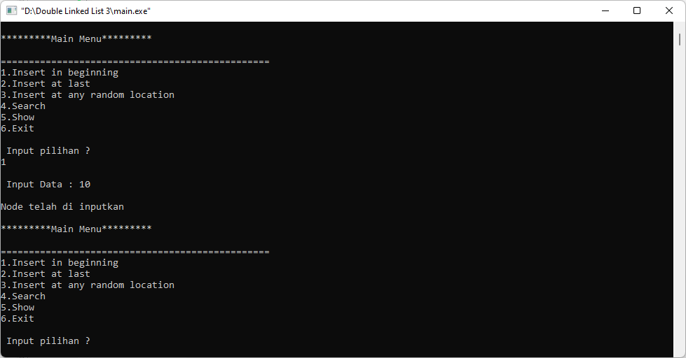

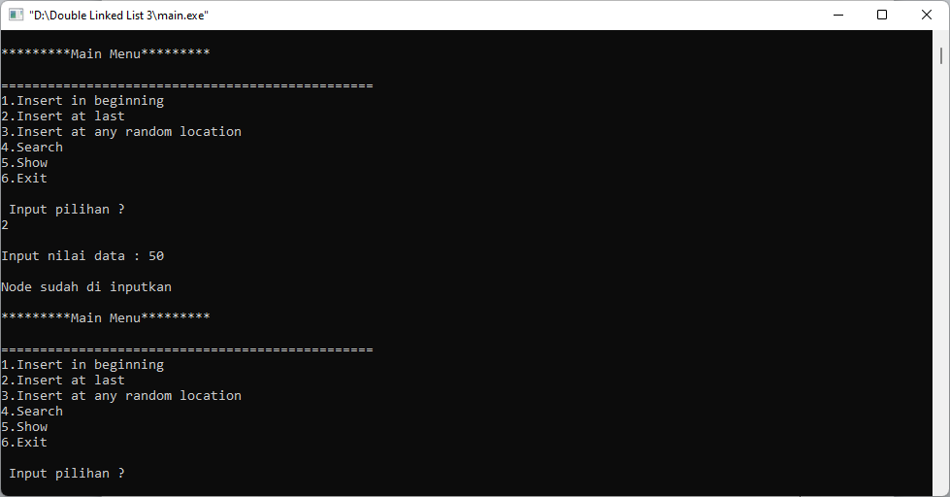

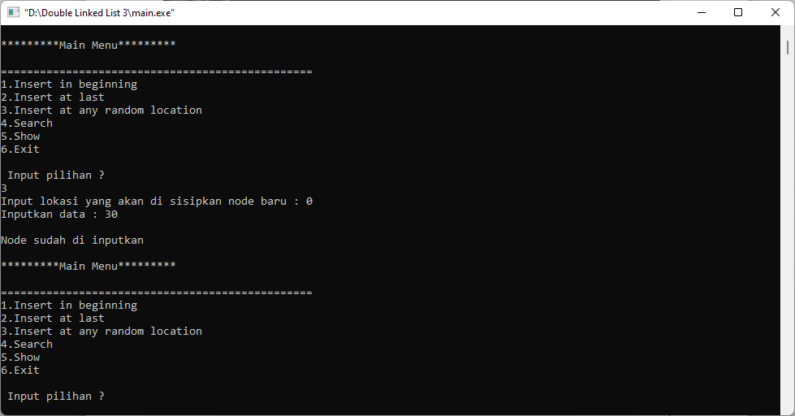

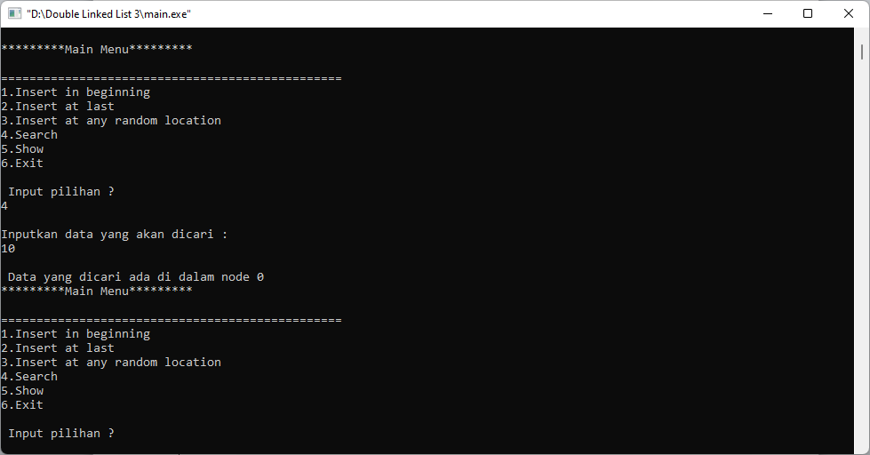

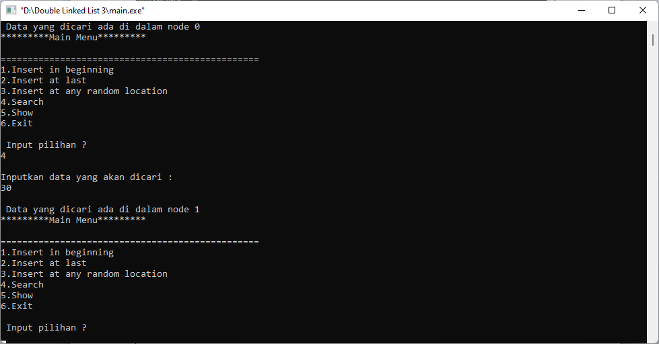

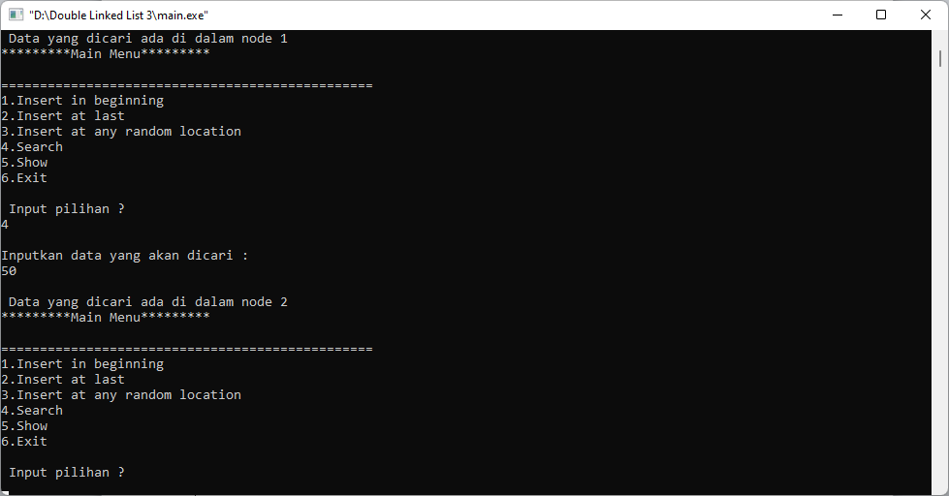

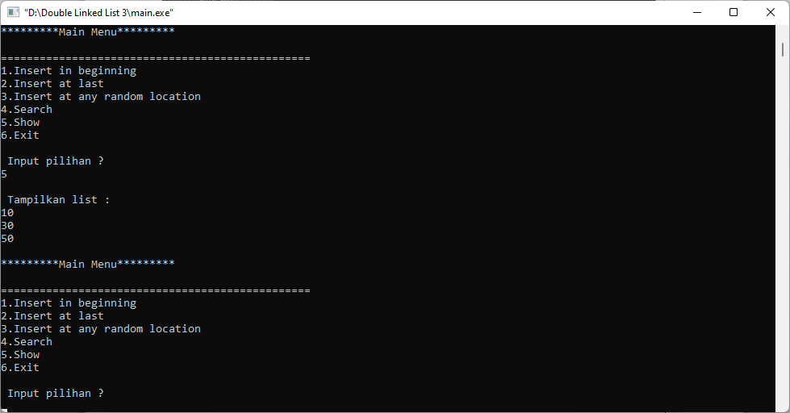

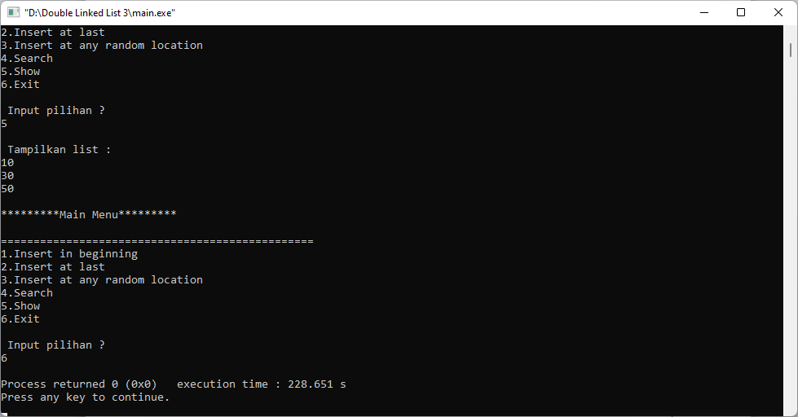

**Dengan Memasukkan Data 0**

